

**User Manual**

**SiLabs Door Lock Application**

|  |  |
| --- | --- |
| **Version**  **Status**  **Date** | 0.1  Draft  24-August-2020 |

**Confidentiality Notice**

Copyright (c) 2020 eInfochips. - All rights reserved

This document is authored by eInfochips and is eInfochips intellectual property, including the copyrights in all countries in the world. This document is provided under a license to use only with all other rights, including ownership rights, being retained by eInfochips. This file may not be distributed, copied, or reproduced in any manner, electronic or otherwise, without the express written consent of eInfochips.

Contents

1 Document Details 6

1.1 Document History 6

1.2 Definition, Acronyms and Abbreviations 7

1.3 References 8

2 Hardware required 9

3 Software required 10

3.1 Simplicity studio 10

3.1.1 Step for importing workspace in Simplicity Studio is given below 10

3.1.2 Steps to build the application 12

3.1.3 Steps to upload the application 12

4 EFR device set up 14

4.1 EFR SET UP WITH FINGERPRINT SENSOR 15

4.2 EFR SET UP WITH KEYPAD INPUT MODULE 17

4.3 EFR SET UP WITH FACE RECOGNITION MODULE 18

4.4 EFR SET UP WITH LED MODULE 19

5 Known Issues 20

6 Limitations and constraints 21

7 Appendix 22

**FIGURES**

Figure 1: Top Level EFR32 Door Lock System Diagram 15

**TABLES**

Table 1: Document History 6

Table 2: Definition, Acronyms and Abbreviations 7

Table 3: References 8

# Document Details

## Document History

|  |  |  |  |  |  |  |
| --- | --- | --- | --- | --- | --- | --- |
| **Version** | **Author** | | **Reviewer** | | **Approver** | |
| **Name** | **Date**  **(DD-MM-YYYY)** | **Name** | **Date**  **(DD-MMM-YYYY)** | **Name** | **Date**  **(DD-MM-YYYY)** |
| Draft 0.1 | Manish Thakur,  Hardik Kumar Patel,  Prassana Sakore,  Vipul Kole | 24-08-2020 | Shachi Mahajan |  |  |  |
|  |  |  |  |  |  |  |

| **Version** | **Description of Change** |
| --- | --- |
| Draft 0.1 | Created initial draft version |
|  |  |

Table 1: Document History

## Definition, Acronyms and Abbreviations

|  |  |
| --- | --- |
| Definition/Acronym/Abbreviation | Description |
| SRS | System requirement specification |
| SDD | Software design document |
|  |  |
|  |  |

Table 2: Definition, Acronyms and Abbreviations

## References

|  |  |  |  |
| --- | --- | --- | --- |
| No. | Document | Version | Remarks |
| 1 | ei_SW_TMP_SystemRequirementSpecification_SiLabs_Door_Lock_Draft_04 | 0.4 | SRS |
| 2 | ei_SW_TMP_DesignSpecification_SiLabs_Door_Lock_Draft_04 | 0.4 | SDD |

Table 3: References

# Hardware required

1. SiLabs SLWSTK6006A Boards
2. R307 fingerprint sensor
3. TTP229 4x4 keypad module
4. Omron B5T face recognition
5. LED’s
6. Jumper cables to connect the SLWSTK6006A board

# Software required

## Simplicity studio

### Step for importing workspace in Simplicity Studio is given below

1. **Open Simplicity studio IDE. Click on file->import option. Snapshot is given below**:

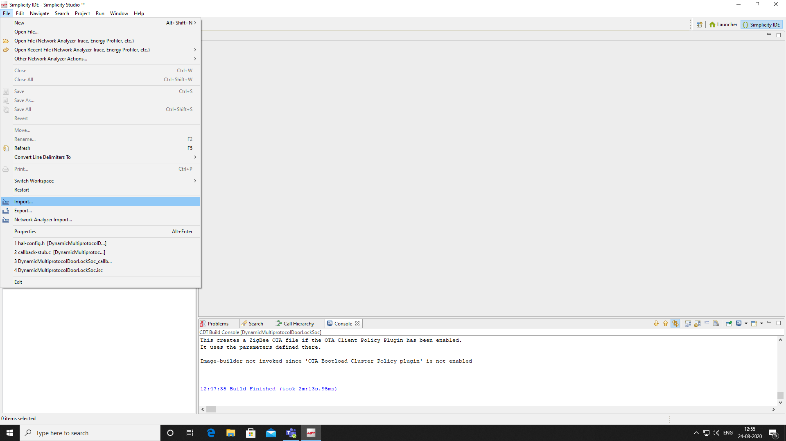

1. **Click on the option showing in detailed project section the .sls file and click next. Snapshot is given below**:

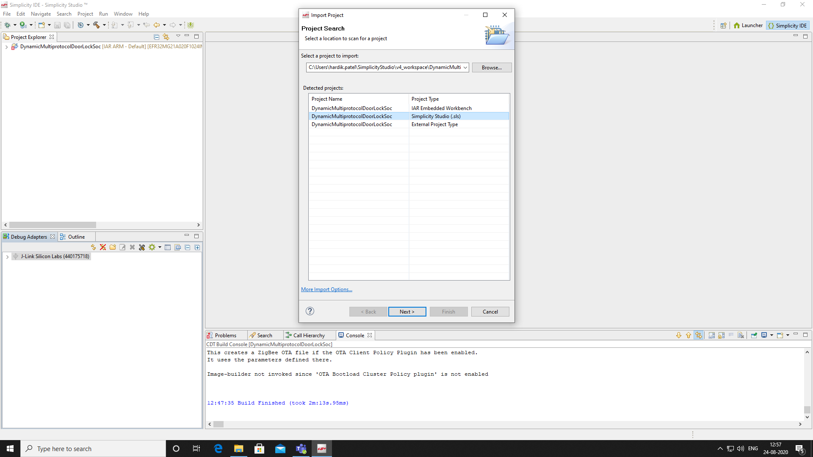

1. **Click Next**

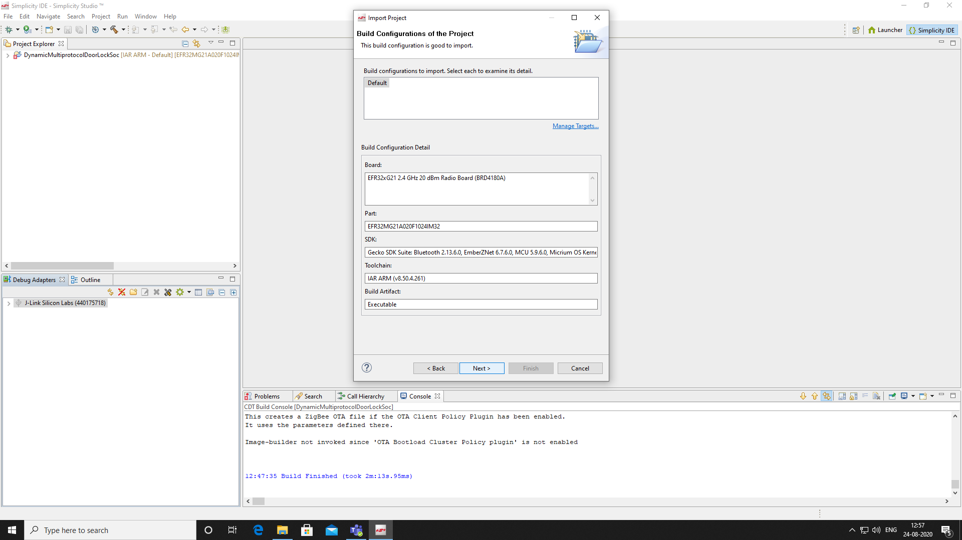

1. **Untick the default location option and provide your relevant path of workspace and also input the project name as the folder name shown in your workspace. After that click on finish button.**

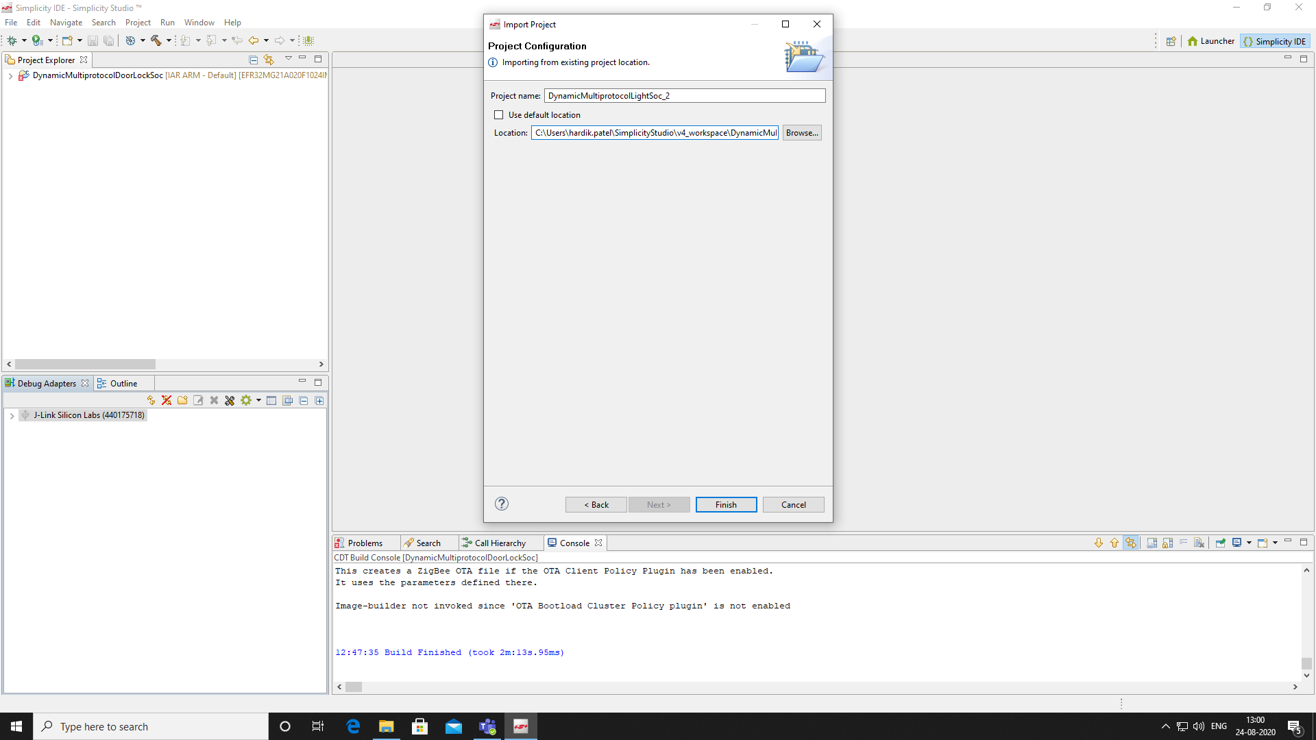

### Steps to build the application

1. **Click the imported project, right click on it and select build project option.**

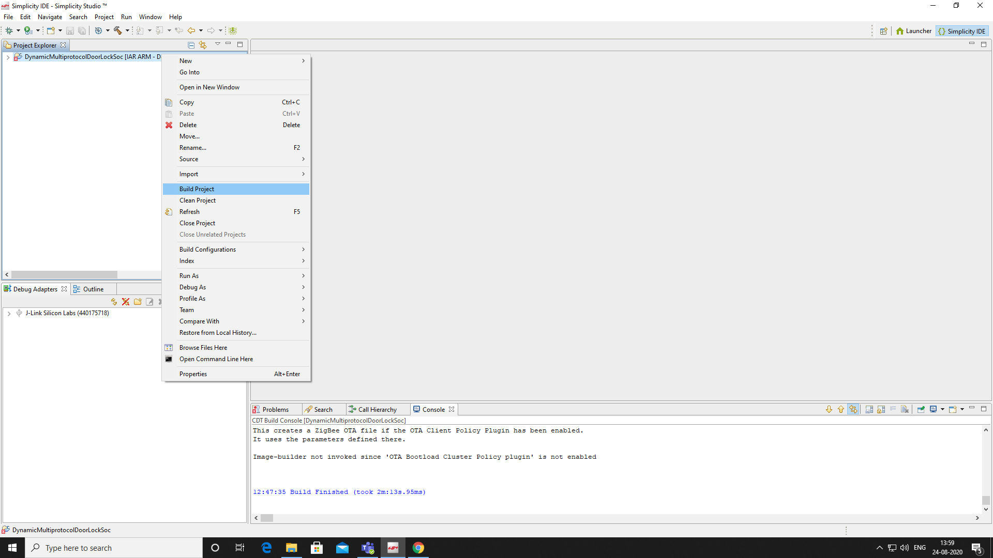

### Steps to upload the application

1. **In debug adapter option select JLink Silicon Labs and right click on it.**

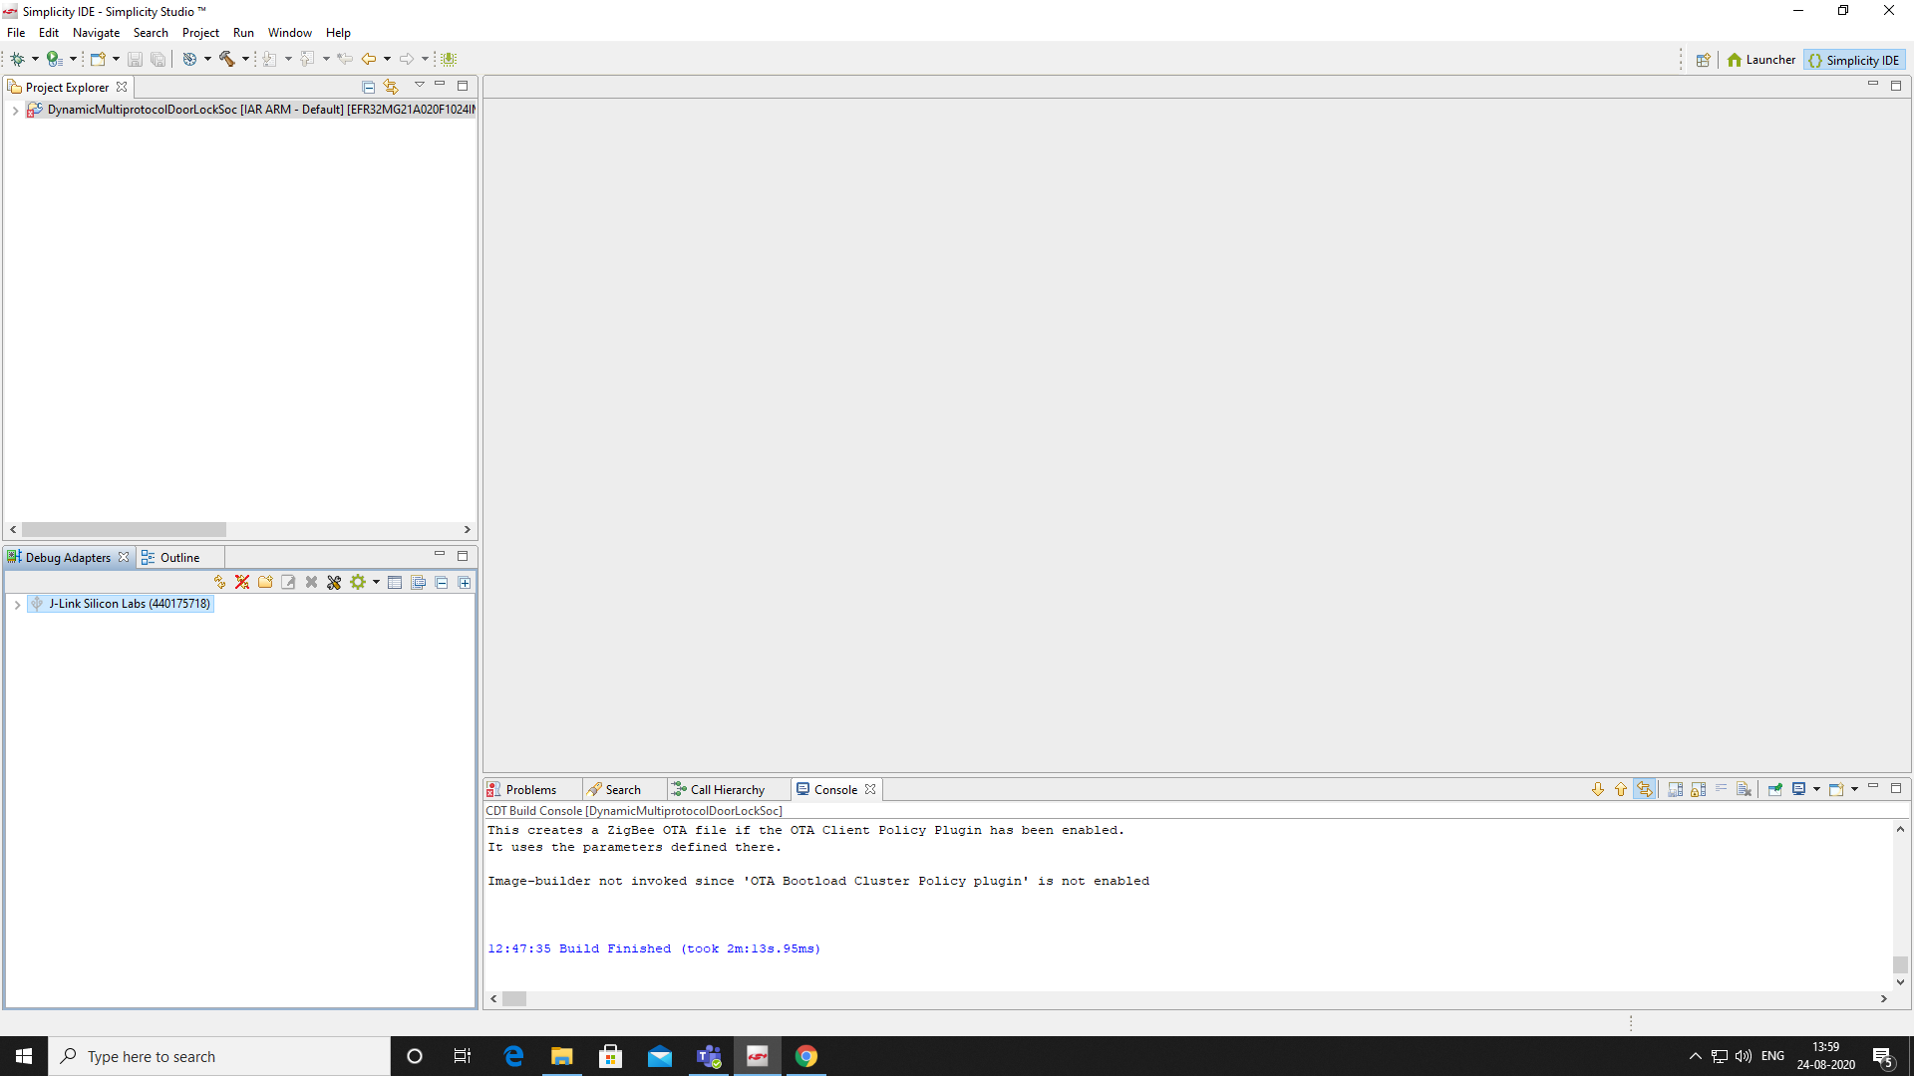

1. **Select the upload application option**

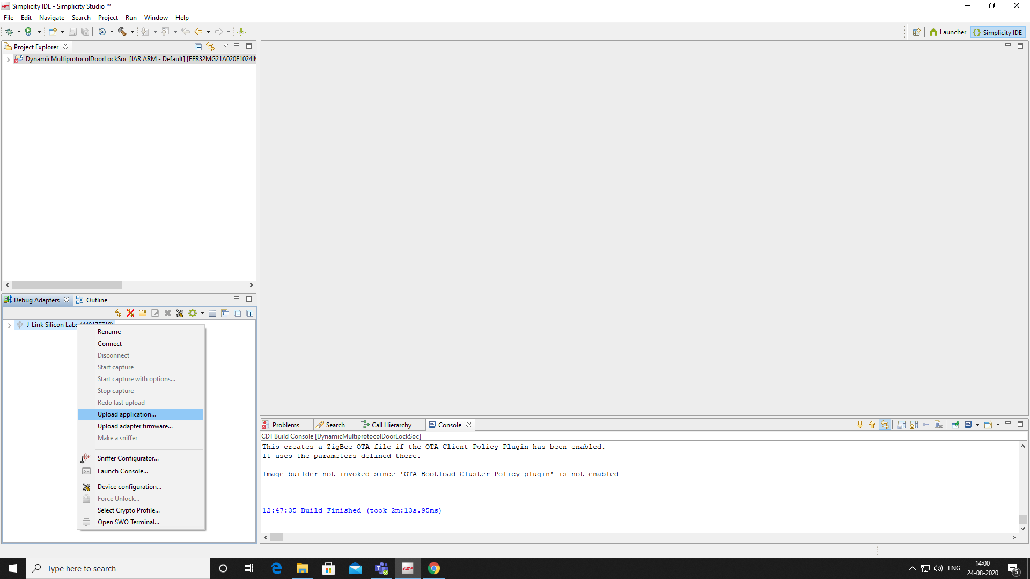

1. **Click on application image path and browse to “IAR ARM - DEFAULT” folder and select .gbl file and then click ok.**

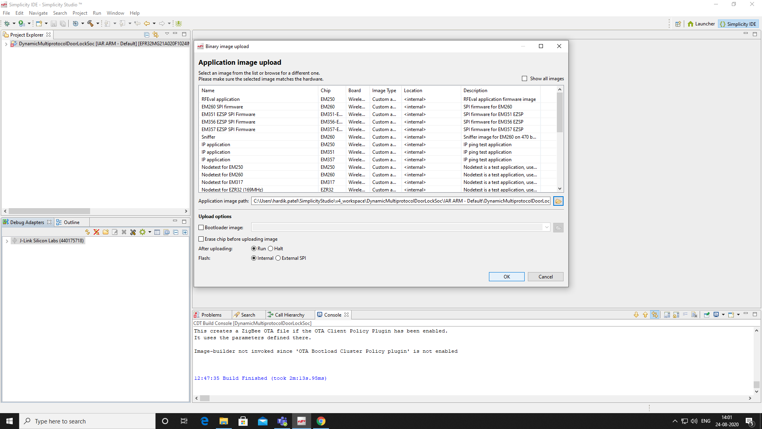

# EFR device set up

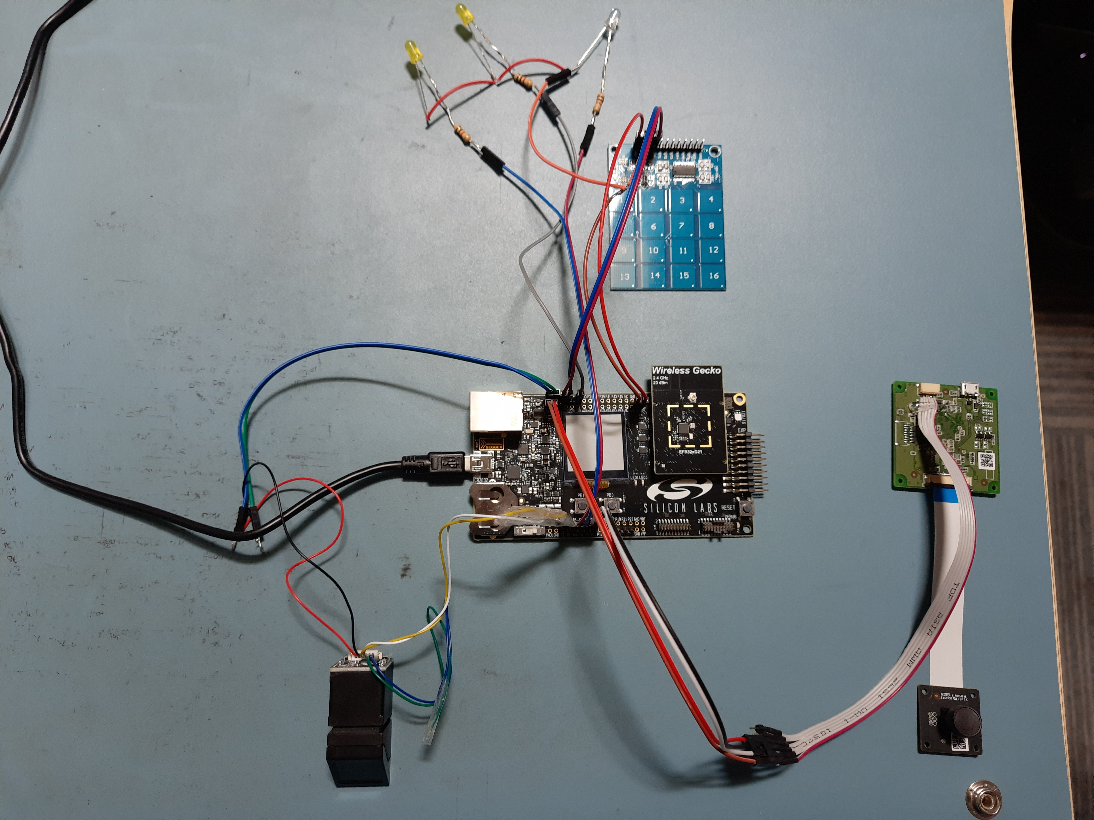

Figure 1: Top Level EFR32 Door Lock System Diagram

The above diagram show the different modules connected with the EFR32MG21 device.

## EFR SET UP WITH FINGERPRINT SENSOR

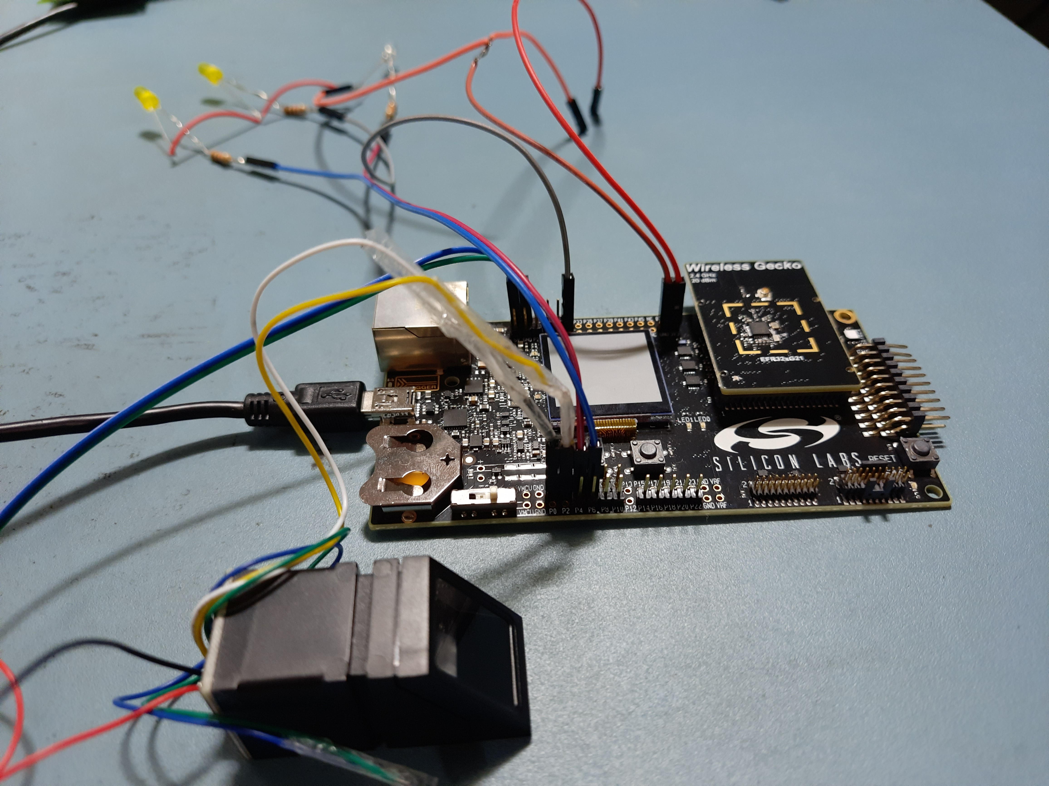

Figure 2: SLWSTK6006A interface with R307 fingerprint diagram 1

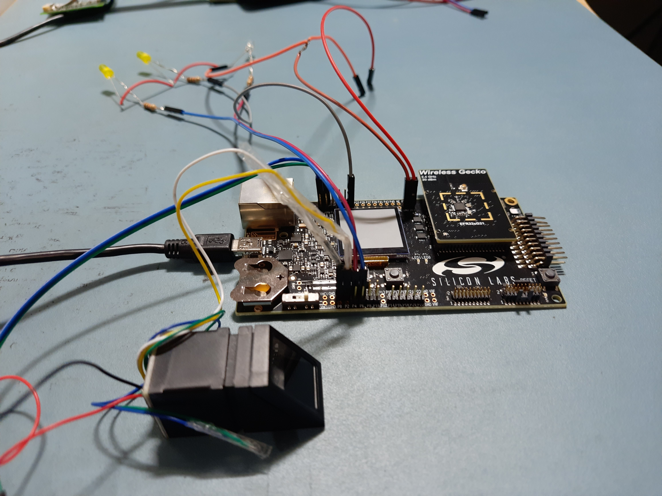

Figure 3: SLWSTK6006A interface with R307 fingerprint diagram 2

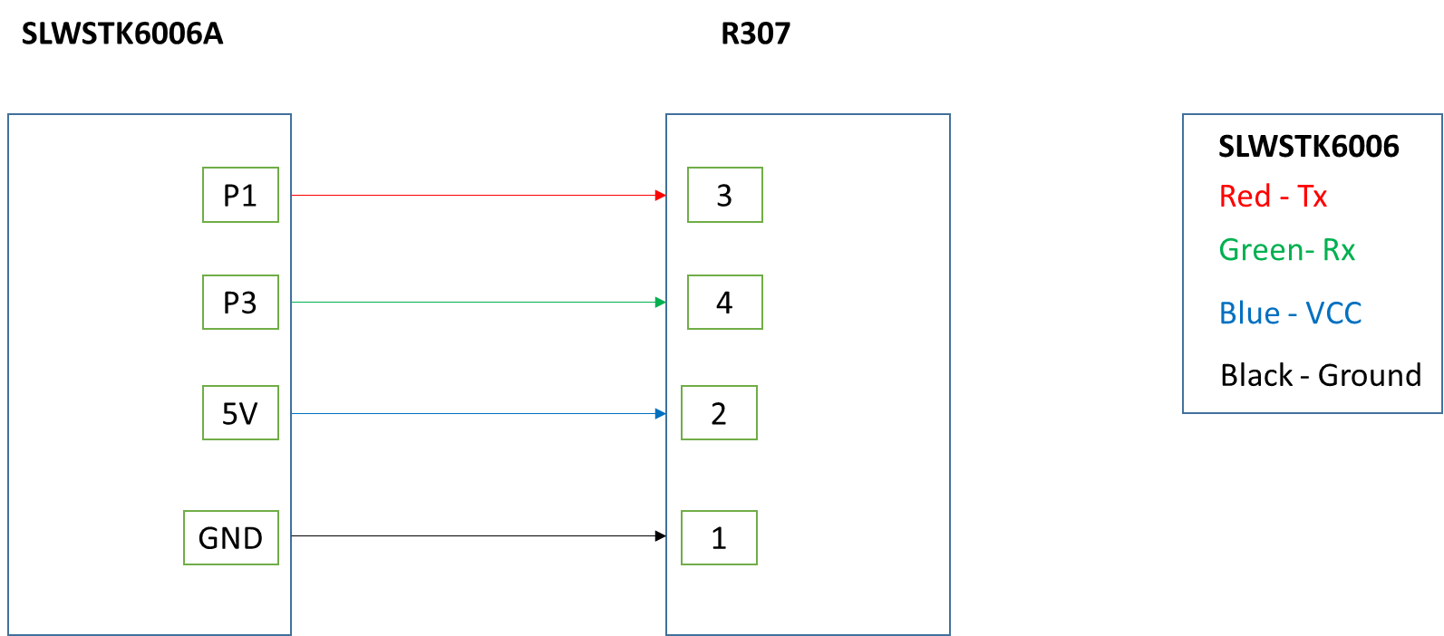

Figure 4: SLWSTK6006A interface with R307 fingerprint pin out diagram

## EFR SET UP WITH KEYPAD INPUT MODULE

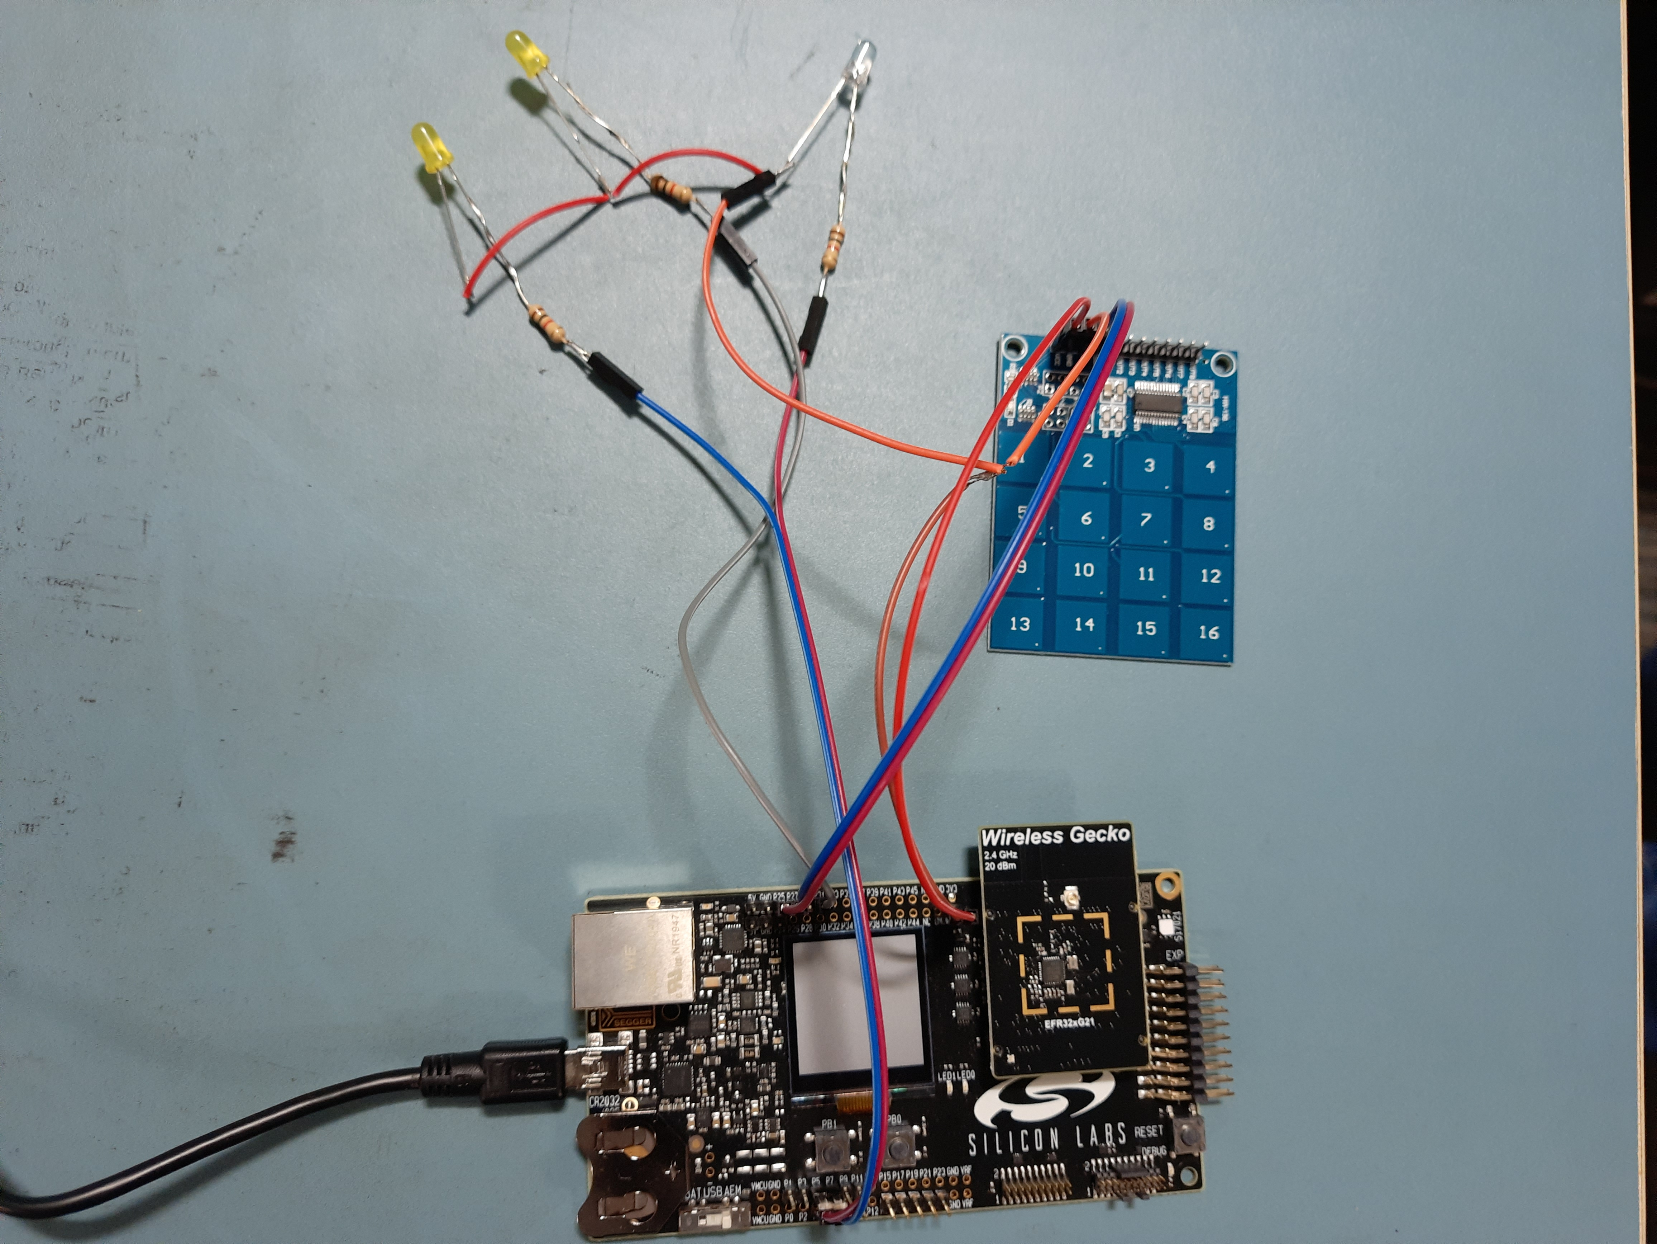

Figure 5: SLWSTK6006A interface with TTP229 keypad module diagram

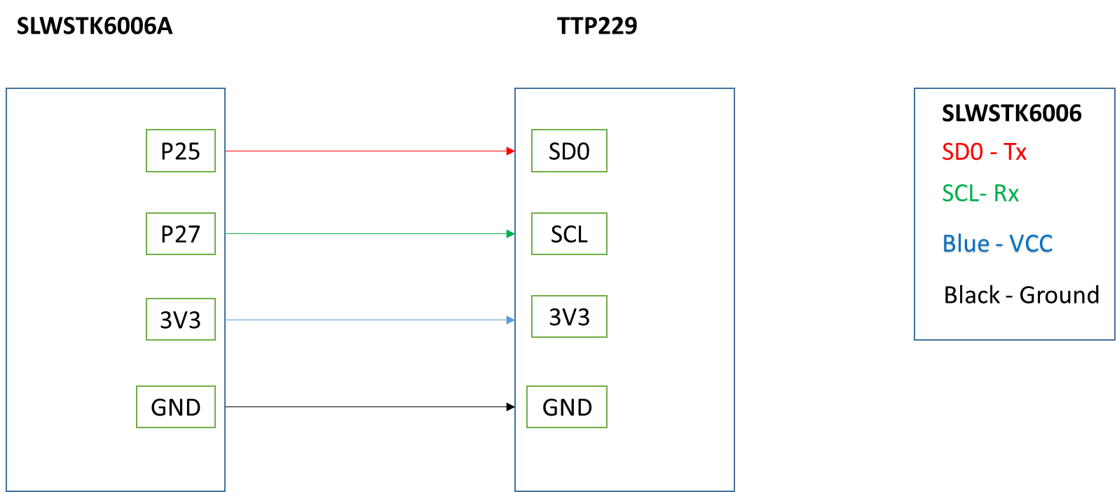

Figure 6: SLWSTK6006A interface with TTP229 keypad module pin out diagram

## EFR SET UP WITH FACE RECOGNITION MODULE

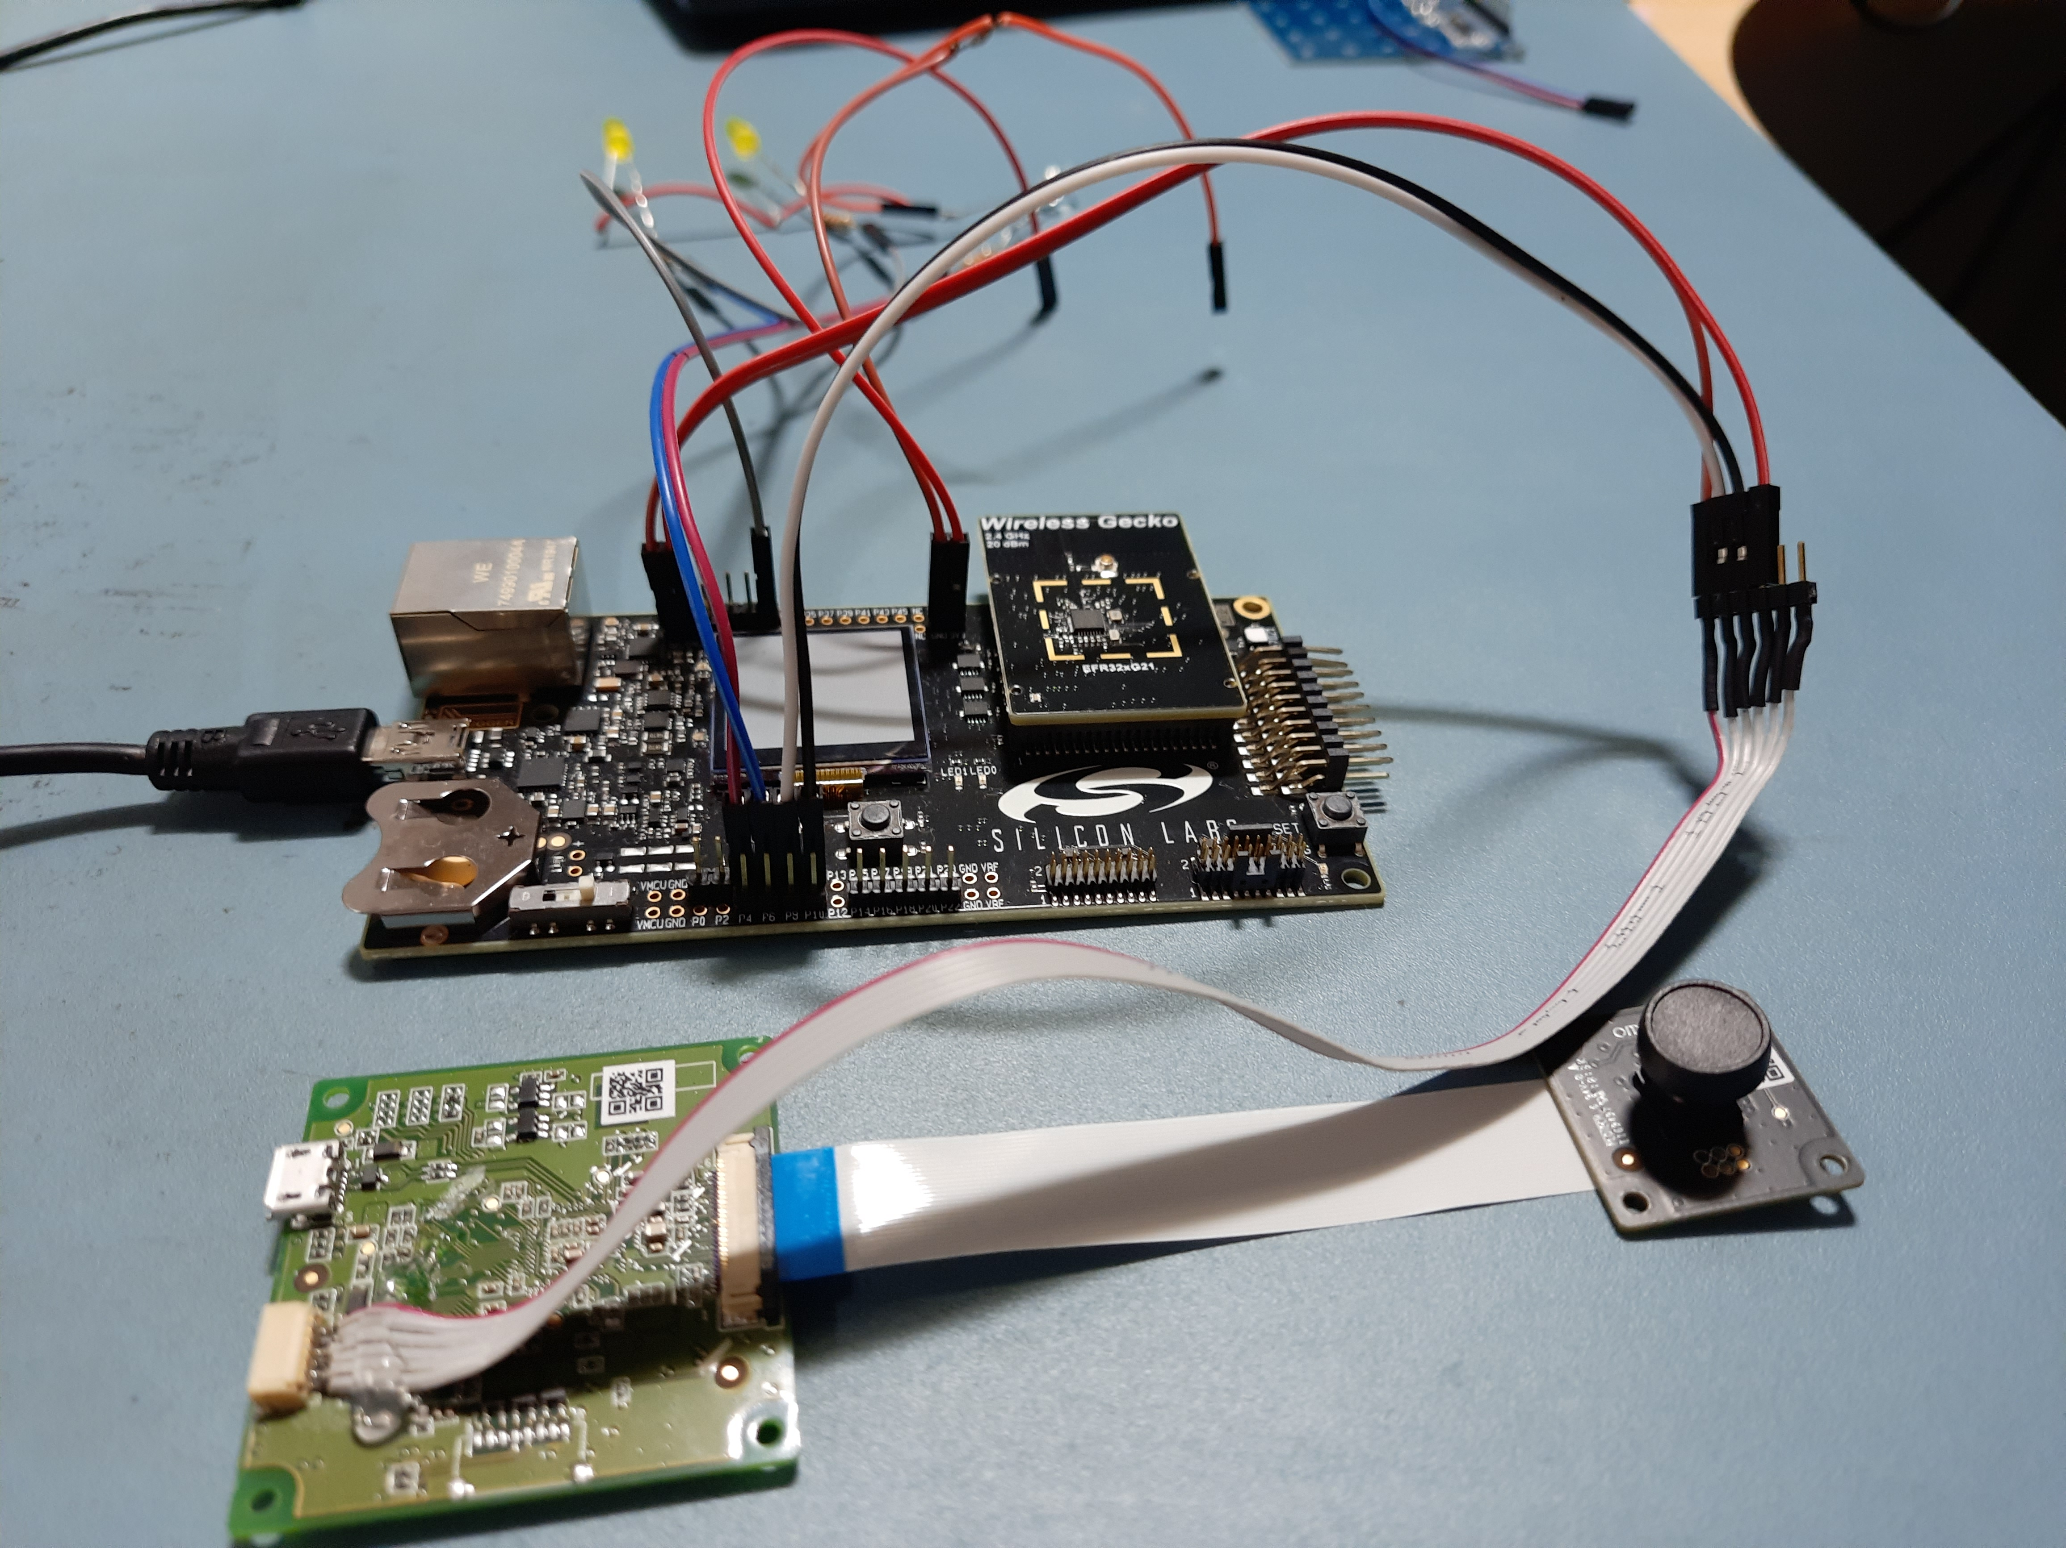

Figure 7: SLWSTK6006A interface with Omron B5T diagram

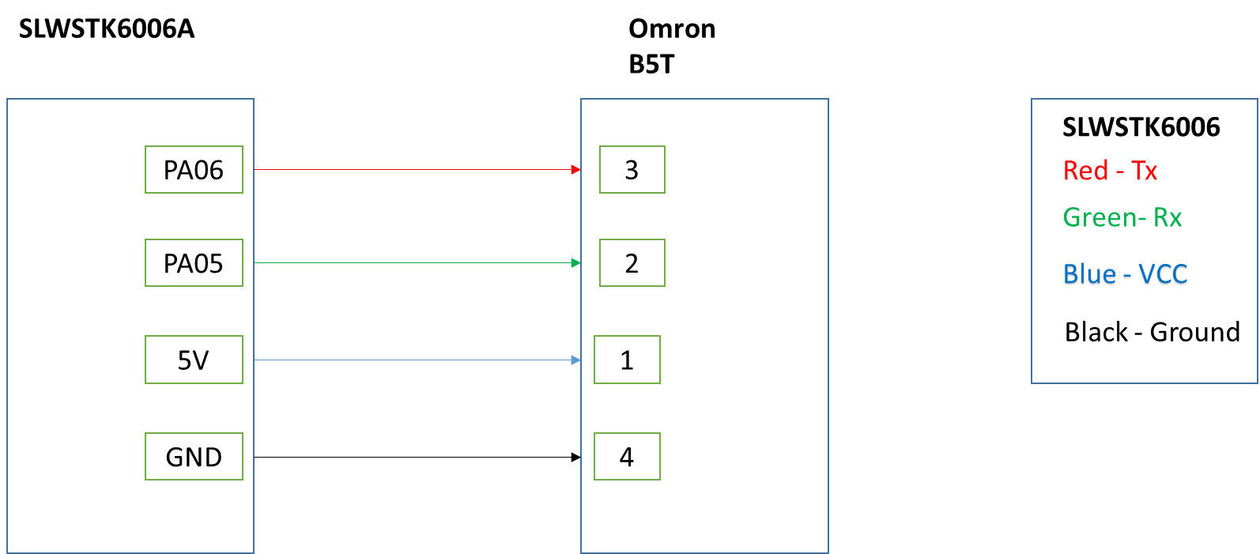

Figure 8: SLWSTK6006A interface with Omron B5T pin out diagram

## EFR SET UP WITH LED MODULE

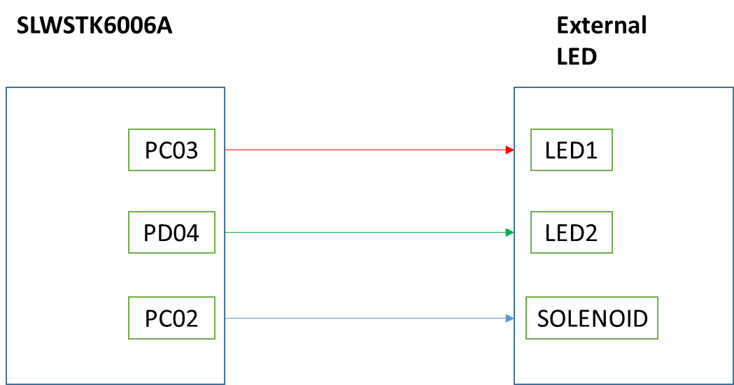

# Known Issues

* Omron B5T face recognition module encounters voltage drop issue when power supply is given from the SLWSTK6006A board.
* Once user update the firmware via OTA, new firmware is not taken from the flash instead it takes the older one.

# Limitations and constraints

NA

# Appendix